**K-Challengers – COVID-19 Dataset Challenge**

CIS 8395 - Big Data Analytics Experience

Catresa Barlow, Laura Liu, Vivian Zhang

Georgia state University

Table of Contents

Business Context 3

Business Problem 3

Kaggle’s COVID-19 Open Research Dataset Challenge (CORD-19) 4

Extract, Load, and Transform 5

Data Sourcing 5

Kaggle 5

World Health Organization 7

Reddit 7

CDC 8

Data Storing 8

Data Stitching 9

Transformed Datasets 9

Data Cleaning and Pre-processing 10

Missing values 10

Duplicates 10

Tokenization 10

High-Level Architecture 10

RStudio 11

Amazon Web Services 11

Databricks 12

H2O 12

Models 12

Clustering 12

Topic Modeling 13

Word/Document Frequency 13

Analytics 13

Datasets 13

Additional Literature Datasets 14

Language Translation 14

Word Correlation 15

Word Correlation 16

Document Term Frequency 16

TF-IDF 17

Clustering 18

Hierarchical 18

k-Means 19

Word2Vec 21

Amazon Web Services 22

Sentiment Analysis 23

Topic Modeling 24

Language Detection 25

Amazon Translate 25

Additional Analysis - Containment Measures 26

Data Visualizations 26

Data Exploration 26

Word Clouds 26

Word Correlations Plot 27

Term Frequency 27

Hierarchical Cluster 28

Containment Measure Map 29

Challenges 30

Updated architecture 30

Results Discussions 30

Future Work 31

Conclusion 31

References 32

# Business Context

The world’s population is currently experiencing a global pandemic that has spread quickly from country to country. COVID-19 is a respiratory disease that is caused by a coronavirus and transmitted when an infected person coughs or sneezes (CDC). While most patients will experience mild to moderate symptoms, some individuals will develop severe illness, and the increasing numbers of COVID-19 patients are threatening to collapse the entire healthcare system in hard-hit places like New York. The demands on the healthcare systems around the world are significant and present a challenge. Hospitals are dealing with shortages of supplies and healthcare workers risk exposure to the virus without proper personal protective equipment (PPE).

Governments have issued stay-at-home orders to their citizens to slow the spread of the virus, and in many countries, including the United States, schools and businesses are closed. As employees lose jobs and companies struggle to respond, the economic impact of the coronavirus is difficult to predict. According to the OECD, many major economies will experience "significant short-term declines in GDP" due to the "increasingly stringent containment measures needed to slow the spread of the coronavirus," and many economies will fall into recession (OECD).

# Business Problem

We must continue to contain the pandemic and prevent further spread of disease, which will save more lives and allow the economy to recover and return to normality. Furthermore, understanding the risk factors for the disease are essential for controlling the transmission of COVID-19.

## Kaggle’s COVID-19 Open Research Dataset Challenge (CORD-19)

The Allen Institute for AI has partnered with Chan Zuckerberg Initiative, Georgetown University’s Center for Security and Emerging Technology, Microsoft Research, and the National Library of Medicine - National Institutes of Health to provide the dataset used in the Kaggle Challenge. The goal of these research groups and the White House is to combat the global pandemic by using data to gain valuable insights about the infectious disease. The COVID-19 dataset contains approximately fifty thousand (50K) scholarly articles on "COVID-19, SARS-CoV-2, and related coronaviruses." The growing volume of coronavirus literature is challenging for the medical research community, which will benefit from the knowledge gain through the Kaggle Challenge. The global research community will apply natural language processing and AI techniques to the dataset to answer “high priority scientific” research questions. The NASEM (National Academies of Science, Engineering, and Medicine) Standing Committee on Emerging Infectious Diseases research topics and the World Health Organization’s R&D blueprint assisted the challenge organizers in developing these research questions (kaggle).

Our team will focus on this research question, “What do we know about COVID-19 risk factors, and what have we learned from epidemiological studies?”. According to the Centers for the Disease Control and Prevention, the following are risk factors for COVID-19

* People aged 65 and older
* Living in communities with high rates of virus transmission
* Traveling to countries with ongoing community spread
* Close contact with a person diagnosed with COVID-19
* Providing medical care to COVID-19 patients
* Living with underlying medical problems like cardiovascular disease, diabetes, chronic respiratory disease, and cancer
* Living in nursing homes and long-term care facilities (CDC)

Through text mining, our team hopes to discover the following as outlined in the challenge task requirements:

* “Data on potential risks factors
  + Smoking, pre-existing pulmonary disease
  + Co-infections (determine whether co-existing respiratory/viral infections make the virus more transmissible or virulent) and other co-morbidities
  + Neonates and pregnant women
  + Socio-economic and behavioral factors to understand the economic impact of the virus and whether there were differences.”
* “Transmission dynamics of the virus, including the basic reproductive number, incubation period, serial interval, modes of transmission and environmental factors”
* “Severity of disease, including the risk of fatality among symptomatic hospitalized patients, and high-risk patient groups”
* “Susceptibility of populations”
* “Public health mitigation measures that could be effective for control” (kaggle)

# Extract, Load, and Transform

## Data Sourcing

### Kaggle

Scholarly Articles

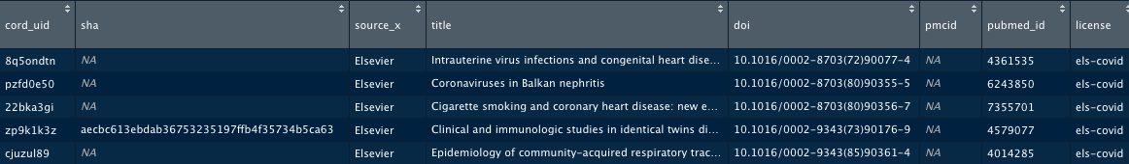

The Kaggle dataset contains approximately fifty thousand (50K) academic articles related to COVID-19, SARS-CoV-2, and other coronaviruses. Our team will use the metadata.csv file (structured data), which has 18 columns of data. For our analysis, we have selected the following five columns.

|  |  |
| --- | --- |
| Column | Description |
| title | title of the journal article |
| abstract | summary of the article’s main points |
| authors | list of article authors |
| journal | name of the publication |
| url | link to article |

Containment Measures

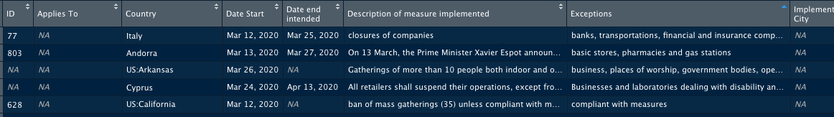

Our team also selected a dataset containing information from 117 countries around the world about various measures implemented in response to COVID-19. Measures include lockdowns, travel bans, social distancing, and school closings. The COVID-19 containment measures data.csv dataset, taken from epidemicforecasting.org, reports measures of “national significance intended to reduce the transmission of COVID-19. The data set contains 1073 observations with 16 columns of data, and for our analysis, we have selected the following five columns:

|  |  |
| --- | --- |
| Column | Description |
| country | country implementing measure |
| description of measure implemented | plain-english description of the measure |
| keywords | keywords associated with the measure |
| source | link to source information |

### World Health Organization

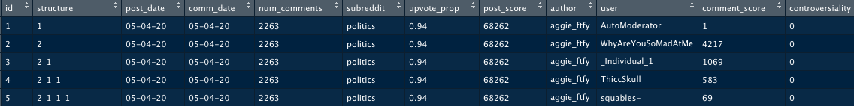

The World Health Organization (WHO) dataset also contains data information on mitigation measures implemented by governments. ACAPS, a non-profit, non-governmental project, created the dataset with 5550 observations of 18 variables that classify the information into five categories, social distancing, movement restrictions, public health measures, social and economic measures, and lockdowns. ACAPS gathered the information by consulting governments, media, the United Nations, and other organizational sources. For our analysis, we have selected the following five columns:

|  |  |
| --- | --- |
| Column | Description |
| country | name of country |
| category | category of measure |
| measures | description of measure |
| source | source of information |
| link | link to source information |

### Reddit



Reddit is an online networking site that allows users to post content to threads organized by topic or subreddits. Using the RedditExtractoR API, our team retrieved approximately 327K comments (with 18 variables) related to COVID-19 using the keywords, COVID-19, covid-19, coronavirus. For our analysis, we have selected the following five columns:

|  |  |
| --- | --- |
| Column | Description |
| subreddit | topic of content |
| author or user | author of post or comment |
| comment | comment text |
| title | title of content |
| url | link to content |

### CDC

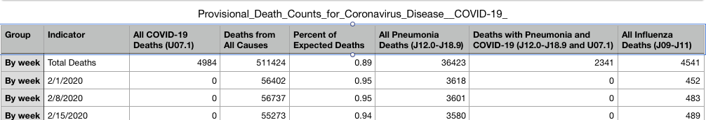

The Centers for Disease Control and Prevention (CDC) provides the Provisional Death Counts for Coronavirus Disease COVID-19 dataset that classifies COVID-19 mortality data by week, age, sex, and state. Our team plans to use the CDC data to enrich the Kaggle, Reddit, and WHO datasets. Our team will use this dataset to investigate whether risk factors differ by indicator or the susceptibility of populations.

## Data Storing

Our team stores the project data in Amazon Web Services’ (AWS) Simple Storage Service (S3). We created a storage bucket for the K-Challengers team. We selected S3 because of ease of use to store and retrieve our project data through either the AWS Management Console or the AWS Command Line Interface. The bucket permissions were adjusted to allow all team members to access bucket objects. In selecting AWS to store the project data, we also considered the low cost of S3 Standard (Amazon Web Service).

* First 50 TB $0.023 per GB
* Next 450 TB $0.022 per GB
* Over 500 TB $0.021 per GB

## Data Stitching

Our team used R to extract, load, transform and stitch the project data. We loaded the data csv and excel files into RStudio. Before combining the four datasets (Kaggle, WHO, and Reddit), we transformed each dataset to a common structure with five columns (title, author, source, text, and link). We combined the transformed data frames into one data frame. We also added a column to indicate from which data source (Kaggle, WHO, or Reddit) the information originated.

### Transformed Datasets

Kaggle – Scholarly Articles

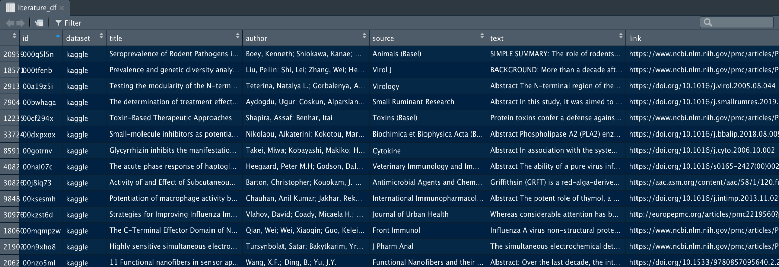

Kaggle – Containment Measures

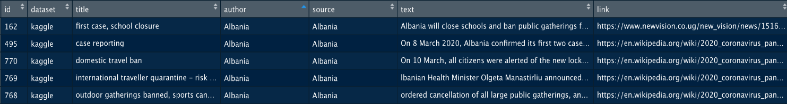

WHO – Government Measures

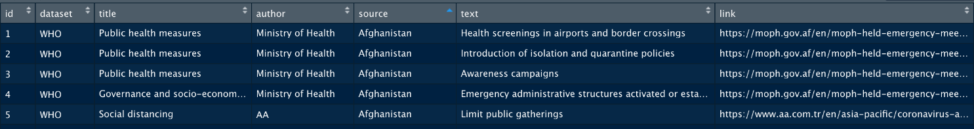

Reddit – COVID-19 Related Posts

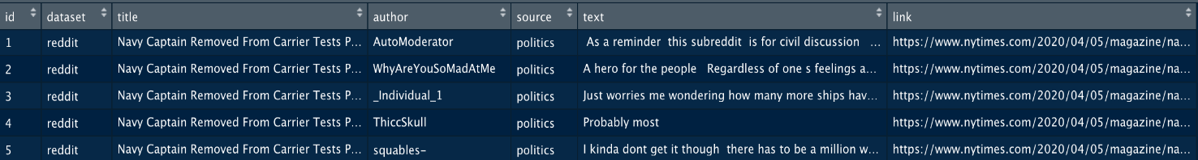

## Data Cleaning and Pre-processing

### Missing values

When our team reviewed the dataset, we found several missing and NA values in the *text* column, and we removed these rows. Removing these rows reduced the dataset from 368,924 observations to 368,695 observations.

### Duplicates

Our team used distinct() to remove the duplicate rows, which further reduced our dataset to 237,789 rows.

### Tokenization

Our team split the document into individual terms or words (tokens), removing punctuation found in the text. We removed stop words (e.g., *I, me, my*, and *the*) along with numbers and rare words, which would not be meaningful for our models.

# High-Level Architecture

We propose to use RStudio, Amazon Web Services, Databricks, and H2O in our project. Below is a diagram of the proposed high-level architecture.



## RStudio

RStudio is an integrated development environment (IDE) for R. We selected RStudio because it is an open source that runs on the desktop version or in a browser connected to RStudio Server (RStudio). R is a popular programming language for data science and comes with ggplot, a visualization library. According to r-project.org, “R provides a wide variety of statistical (linear and nonlinear modeling, classical statistical tests, time-series analysis, classification, and clustering)” (r-project.org). The CRAN package repository contains more than 15k packages, including reticulate, an interface to Python that will allow our team the flexibility to use both languages in our project (Cran.r-project.org).

## Amazon Web Services

Our team selected the following AWS services for our project.

* Simple Storage Service (S3) –As mentioned earlier, our team stores project data in an AWS S3 bucket. We initially retrieved the project data and stored the data on a local disk drive. Using the AWS command line or the AWS console, we uploaded the data to the storage bucket. We plan to directly access the data from the S3 bucket using a Databricks notebook. Once our analysis is complete, we will also store the output in the K-Challengers’ AWS S3 bucket.
* EC2 offers scalable cloud computing on-demand with virtual Linux servers. We will examine using an EC2 instance to connect with RStudio Server. We expect to incur a minimum cost in utilizing the EC2 due to the variety of low-cost options.
* Comprehend is AWS’s Natural Language Processing Service that uses "machine learning to find insights and relationships in the text (Amazon Web Services).” According to AWS, Amazon Comprehend automatically extracts key phrases, topics, and document classifications, and we will attempt to use the service for natural language processing and topic modeling. The cost of using the service is low, and AWS offers a free tier (Amazon Web Services).

## Databricks

Our team proposes to use the no-cost Databricks Community Edition for our analysis. Databricks supports both Python and R and offers an RStudio integration that allows our team to use a familiar IDE. We will investigate whether the RStudio integration is available with the community edition. If not, we will consider sharing the notebook between Databricks and RStudio by exporting/importing an RMarkdown file.

## H2O

H2O offers an open-source machine learning platform and is accessible from RStudio that supports random forest, gradient boosting machines, and deep learning. H2O also ingests data directly from S3. Our team proposes to use H2O to perform document classification or clustering and word/document frequency (h2o).

# Models

Our team will use the below Natural Language Processing/Text Mining techniques to understand our data and gain insights. We hope to use the dataset to investigate:

* What are the risk factors for COVID-19?
* Do risk factors differ by demographics?
* What mitigation measures have been effective in countries that have slowed the transmission of the virus?
* How do transmission dynamics differ from country to country?

## Clustering

Our team will use clustering to group similar data points (e.g., literature) together & discover underlying patterns.

## Topic Modeling

Our team will use topic modeling to divide the data into natural groups and identify the main themes of the data. Latent Dirichlet allocation is an algorithm that we intend to use for this model.

## Word/Document Frequency

Our team will use tf-idf to understand the importance of a word in the text data by considering word frequency and adjusting the weight accordingly (decreased weight for common words, increased weight for rarer words) (Robinson).

# Analytics

## Datasets

Our team modified our dataset to include additional scientific literature data from the Centers for Disease Control and Prevention (CDC), the World Health Organization (WHO), and the Lens. The CDC, WHO and The Lens, all provide datasets containing scholarly articles from sources such as the Journal of the American Medical Association (JAMA), Journal of Medical Virology, Journal of Infection, and medRxiv. The data visualization section contains a visualization of the various publisher sources.

We also removed the Reddit comments from our original dataset and created a separate dataset for containment measures data. We focused our analysis on scholarly articles to understand risk factors for COVID-19 and the containment measures data to understand effective measures. We will reserve the remaining datasets for future work.

We followed the same stitching procedure discussed earlier to create the literature dataset, transforming the retrieved literature data to a common structure, then combining all rows. Below are snapshots of the three additional datasets (transformed).

### Additional Literature Datasets

#### World Health Organization (WHO)

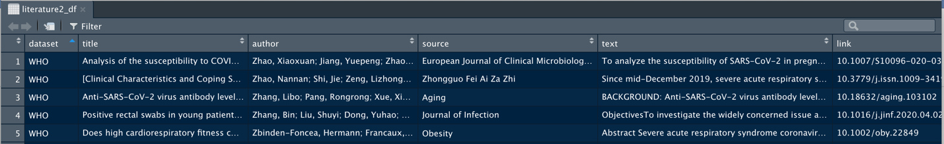

#### The Lens

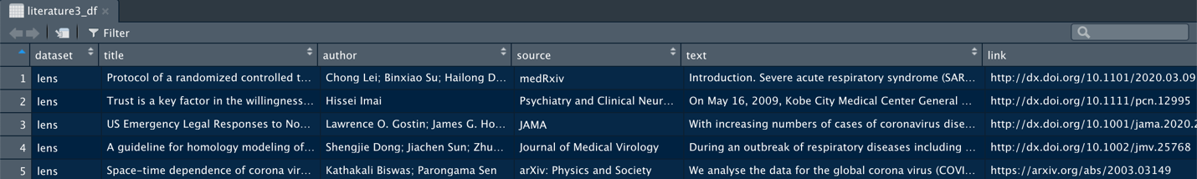

#### Centers for Disease Control and Prevention (CDC)

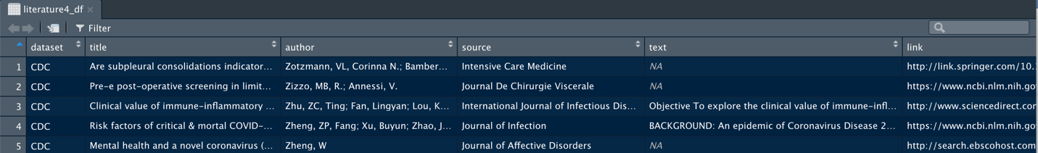

After stitching the literature dataset, we noted that the different data sources collected many of the same articles. We checked the approximately 80K rows for duplicate and NA entries and removed approximately 27K such rows.

### Language Translation

While exploring the dataset, we noted that there was a difference of approximately 3k articles between the literature data frame and the exported csv file used for analysis. We believe the difference is due to rows of non-English language literature. Our team used Google's Compact Language Detector (CLD) in R to identify the language of each record. Once we identified the primary language, we created a separate data frame containing all rows with non-English languages. Of the 52,477 rows in our dataset, CLD identified 49,947 rows as containing English, 2,206 non-English or unidentified rows, and 324 rows with missing text. We will translate the appropriate rows at a later time, then add them to our dataset.

#### Missing Text

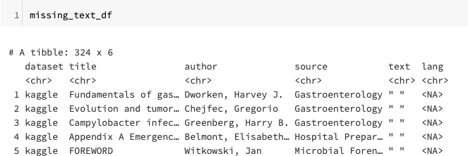

#### Non-English literature

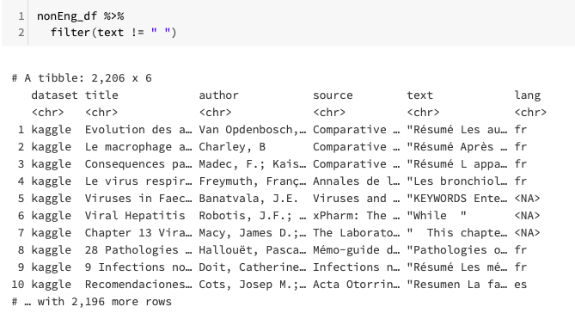

## Word Correlation

We used word correlation to understand the relationship between the articles in the dataset, assessing correlation within and across documents. For our research question, we wish to discover from the literature the COVID-19 risk factors. We filtered the word correlation for insignificant words such as “must”, “appropriate”, “prospective”, and “provide”, etc. as shown below.

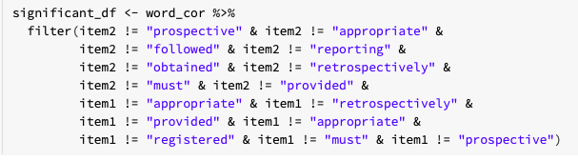

Below is the first 6 of 634 rows of the word correlation.

### Word Correlation

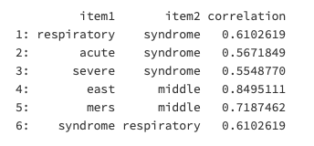

A search for words highly correlated with “risk” or “factor” yielded no results.

##### Search Results

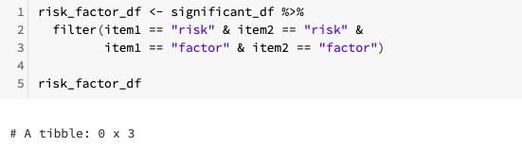

## Document Term Frequency

Our team prepared a document term matrix to determine the importance of words used in the literature documents. According to the matrix snapshot below, the rows list the literature documents, and the columns contain the frequency with which that term appears in the document. For example, the term “patients” appears in document *kaggle18057*, a total of 168 times.

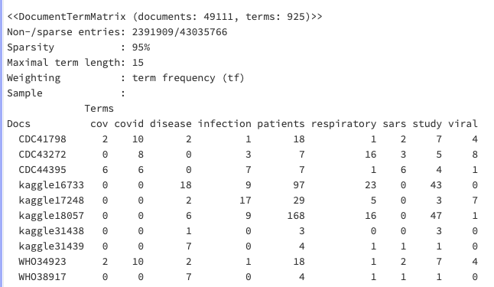

We searched the matrix for keywords, “risk” and “factor” and identified documents that frequently used these terms as noted below. Now that we have identified articles, we can do additional analysis to determine how the terms are used and what the articles can tell us about risk factors.

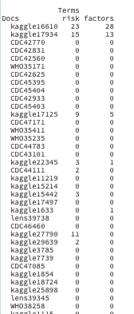

## TF-IDF

Our team also used tf-idf to understand the importance of a word in the text data by considering word frequency and adjusting the weight accordingly (decreased weight for common words, increased weight for rarer words) (Robinson).

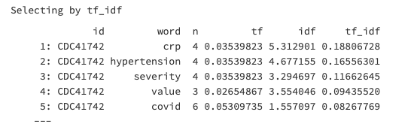

We then searched for the terms “risk” and “factor” to identify literature documents that used these terms frequently. Below are the first ten (10) documents returned by our search. We can now investigate these documents further to understand what they can tell us about risk factors.

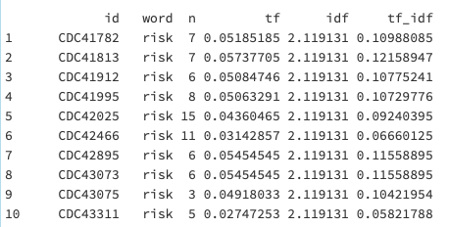

## Clustering

Our team performed clustering to group similar data points (e.g., literature) together & discover underlying patterns. We used two different types of clustering in our analysis, Hierarchical, and K-Means.

### Hierarchical

In hierarchical clustering, documents are sequentially grouped into clusters based on the distance between documents and between clusters. Using the document term frequency matrix created earlier, we used the *dist* function in R to create a distance matrix, and we selected the Euclidean method to calculate distance. The function computes and returns the distance matrix “by using the specified distance to compute the distances between the rows of the data matrix” (RStudio). Due to the large number of documents, we reduced the dataset by creating a subset of 30 rows. We grouped the documents into 10 clusters using *Ward’s* method, which measures the difference between documents and a group mean (Shmueli, Bruce and Yahav). Below are the top five (5) words defining each cluster. We created a dendrogram visualizing the ten (10) clusters which appears in the visualization section.

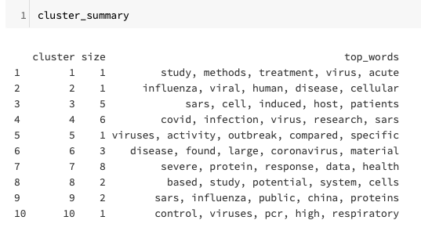

### k-Means

In *k-*means clustering (non-hierarchical approach), documents are assigned to one of *k* number of clusters “according to their distance from each cluster” (Shmueli, Bruce and Yahav). We have approximately 50k documents and used h2o.ai to create the model. Using the document term frequency matrix created earlier, we transposed the matrix from documents in rows and terms in columns to terms in rows and documents in columns. This modification will allow us to create clusters of documents instead of clusters of terms. First, we selected to cluster our dataset into ten (10) clusters (to create non-overlapping clusters of similar articles). The results show the majority of the documents appear in one cluster. We attempted to obtain better results by adjusting the number of clusters. Increasing the number of clusters or *k* changed the results only slightly, and decreasing *k* had the opposite effect, increasing the number of documents in one cluster.

##### *k* = 10

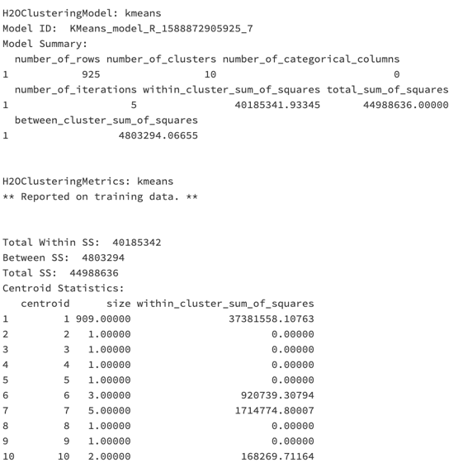

##### *k* = 25

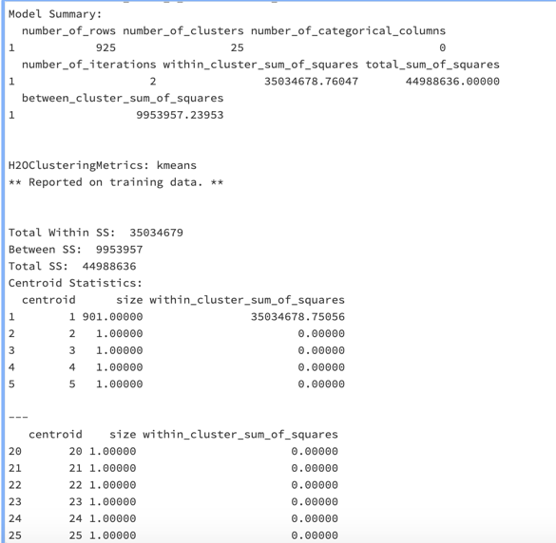

##### *k* = 6

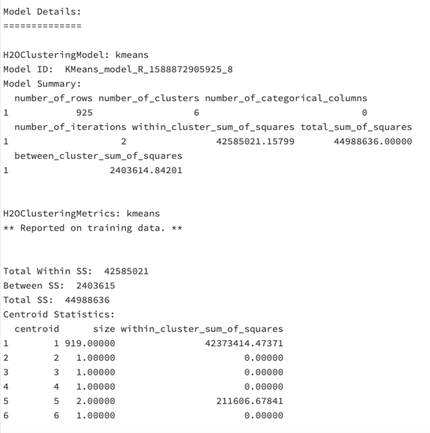

We researched methods to improve our model and found a technique that uses the output from the word2vec model in our *k*-means model (discussed below). Using the word2vec model as our input, we improved the clustering results. We will continue working to improve this model.

##### *k* = 10 (word2vec)

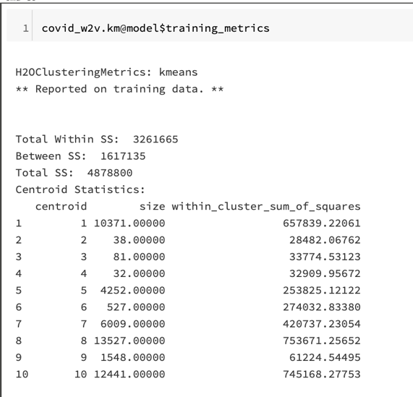

## Word2Vec

In H2O.ai, our team created a word2vec algorithm that takes a text corpus as input and creates word vectors as output. We converted our COVID-19 literature data frame to an H2O object, then tokenized the abstract text. “Words with similar contexts are placed in close proximity to each other in space” (h2o). We used this model to find words similar to the terms “risk” or “factors, such as “smoking”, “exposure”, “drivers”, “variables” and “determinants”. Using these terms, we can further explore the literature dataset to identify risk factors for COVID-19.

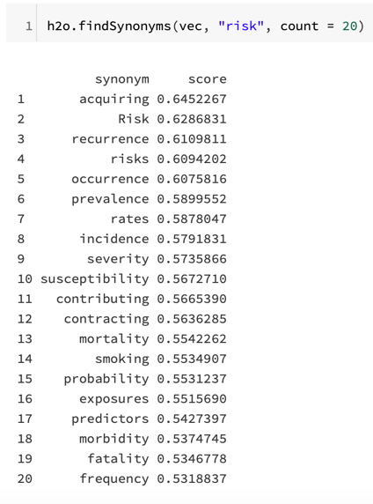 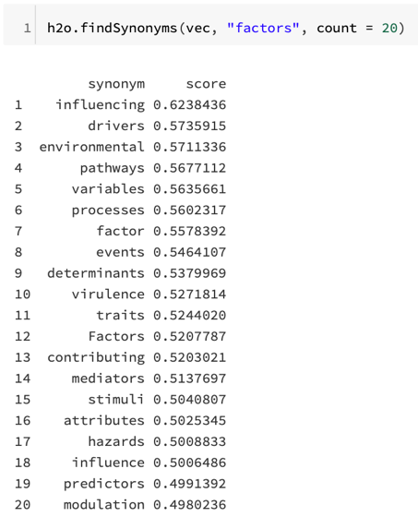

## Amazon Web Services

##### Brief Amazon Comprehend Overview

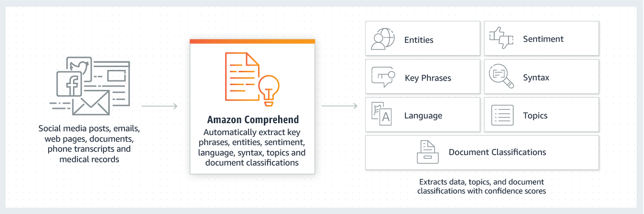

Source: AWS

We used Amazon Comprehend to analyze the literature datasets in our project. Amazon Comprehend is a natural language processing (NLP) service that uses machine learning to find insights and relationships in text. Amazon Comprehend provides Keyphrase Extraction, Sentiment Analysis, Entity Recognition, Topic Modeling, and Language Detection APIs. that allows us to easily integrate natural language processing. We simply call the Amazon Comprehend APIs in our application and provide the location of the source document or text. The APIs will output entities, key phrases, sentiment, and language in a JSON format. In our project, we chose to use Sentiment Analysis, Language Detection, and Topic Modeling to do data analytics.

## Sentiment Analysis

Our team created analysis jobs based on datasets that we collected. Here is an example, which is an article from the datasets, and we performed sentiment analysis to determine whether the sentiment is positive, negative, neutral, or mixed. We created a text file first, then uploaded this file to the Amazon S3 bucket. Next, we switched to Amazon Comprehend and created a sentiment analysis job. The output was returned to the S3 bucket.

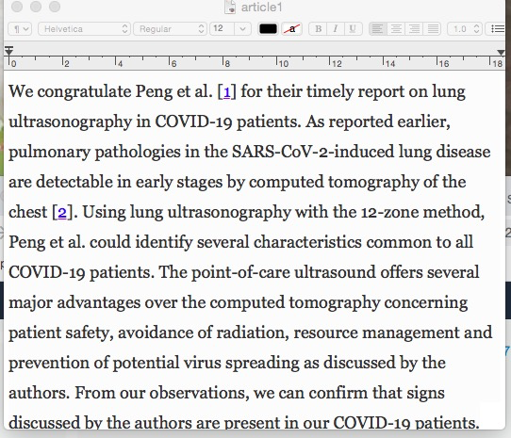

Below is the output of sentiment analysis, and we can conclude that the sentiment of this article is neutral, with 99% confidence. Because all of the literature documents in our datasets are academic articles, our expectation is the majority will have a neutral sentiment.

##### Output:

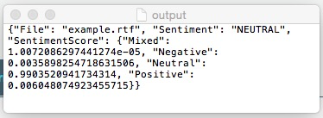

## Topic Modeling

Topic Modeling is another analysis job that we created to examine the content of a collection of documents to determine common themes. The output was also returned to the S3 bucket. Our team chose ten (10) topics to analyze although, Amazon Comprehend allows customers to choose up to a maximum of 100 topics.

Below is the output of the Topic Modeling analysis. Keywords are associated with a topic and the weight indicates the “prevalence of the keyword within the group” (AWS). Weights closer to “1” indicate the topic’s context (AWS). Amazon Comprehend automatically organizes a collection of text files by topic. We will perform additional analysis to determine which topics are associated with COVID-19 risk factors.

##### Output:

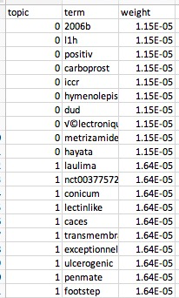 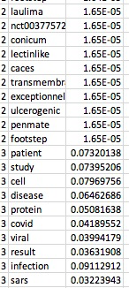 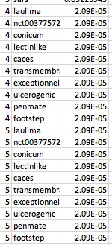 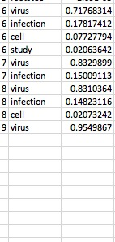

## Language Detection

As discussed earlier, there are over 2k rows of non-English language, such as Chinese, Japanese, Spanish, in our dataset. In addition to Google's Compact Language Detector (CLD), we can use Amazon Comprehend to identify the languages in our dataset. Using one of the non-English language documents in our dataset, we can see from the below results that the language used is French with 94% confidence.

##### Output

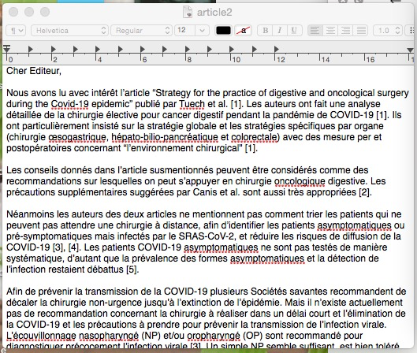 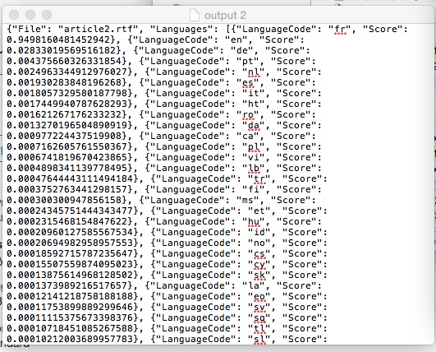

## Amazon Translate

After identifying language in the sample document as French, we used Amazon Translate to translate the text into English. Below is the result of this translation work.

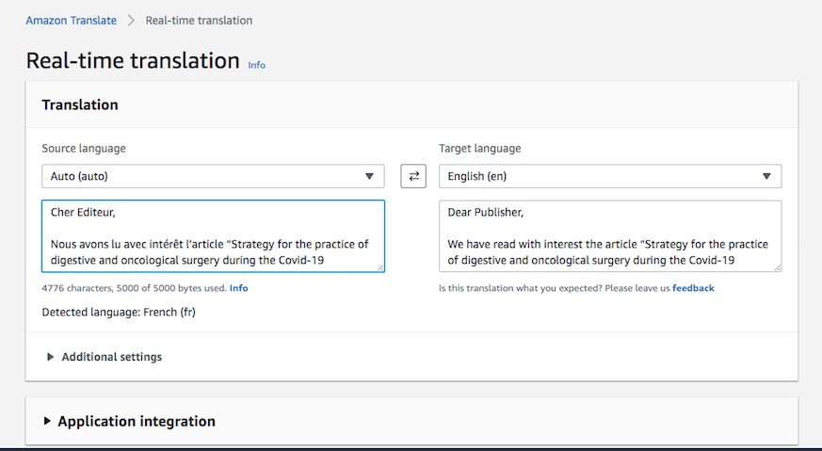

## Additional Analysis - Containment Measures

Our team performed analysis of the containment measure dataset to enrich our literature dataset analysis. We want to understand the most prevalent measures and identify the “public health mitigation measures that could be effective for control” of COVID-19(kaggle). The words used most frequently in the dataset include “closure,” “international,” “countries,” “isolation,” “public,” “travel,” and “school”. We will perform additional analysis to determine the measure implemented in countries that have controlled the transmission of COVID-19.

# Data Visualizations

### Data Exploration

We explored the data and produced the below visualization showing the various publishers contributing the literature documents. The results show that the Journal of Virology is the top contributor of scientific articles.

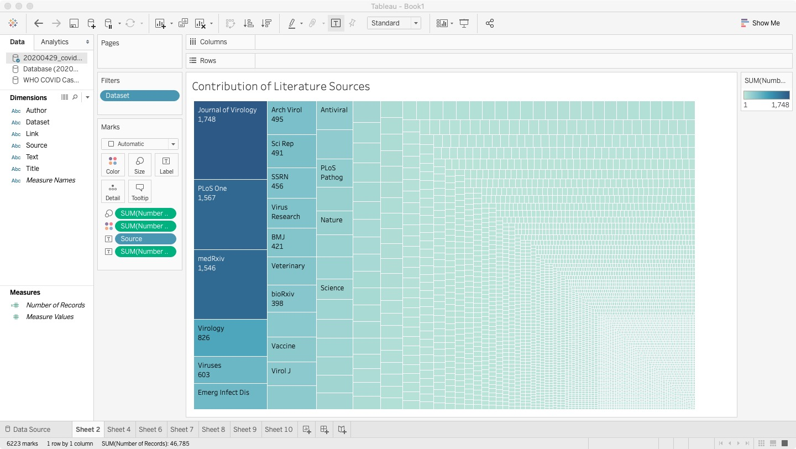

### Word Clouds

To visualize the data, we also created a word cloud of the most common words for the literature documents and containment measures datasets.

|  |  |
| --- | --- |
| Literature Dataset | Containment Measures Dataset |
|  |  |

### Word Correlations Plot

The word correlation plot shows expected correlations between words such as “Wuhan and China” and “Public and Health”. In future work, we will can plot words highly correlated with risk factors.



### Term Frequency

Below is a visualization of the term frequency for terms appearing greater than 12,000 times in the literature dataset.

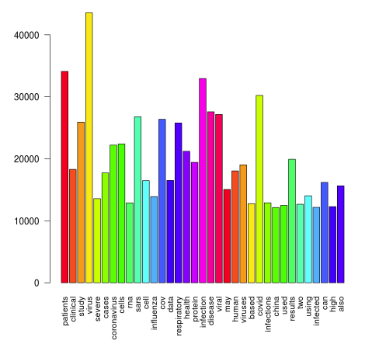

We also visualized the term frequency for the containment measures dataset.

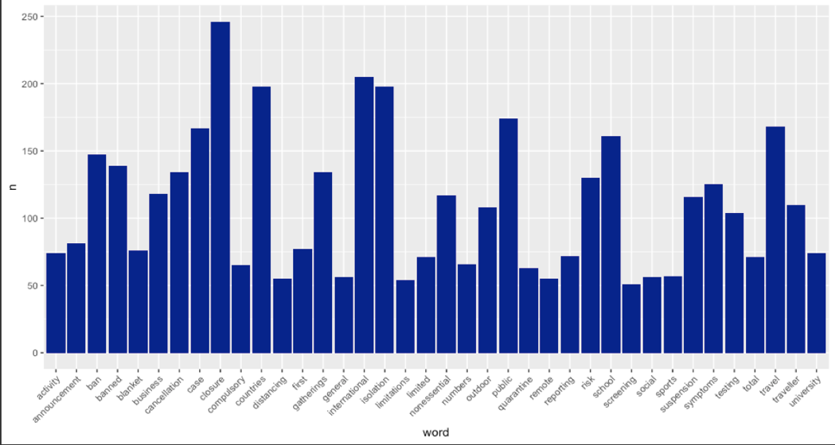

### Hierarchical Cluster

The below visualization shows the hierarchical clustering of 30 rows of our dataset. We have assigned the literature documents into one of four (4) clusters.

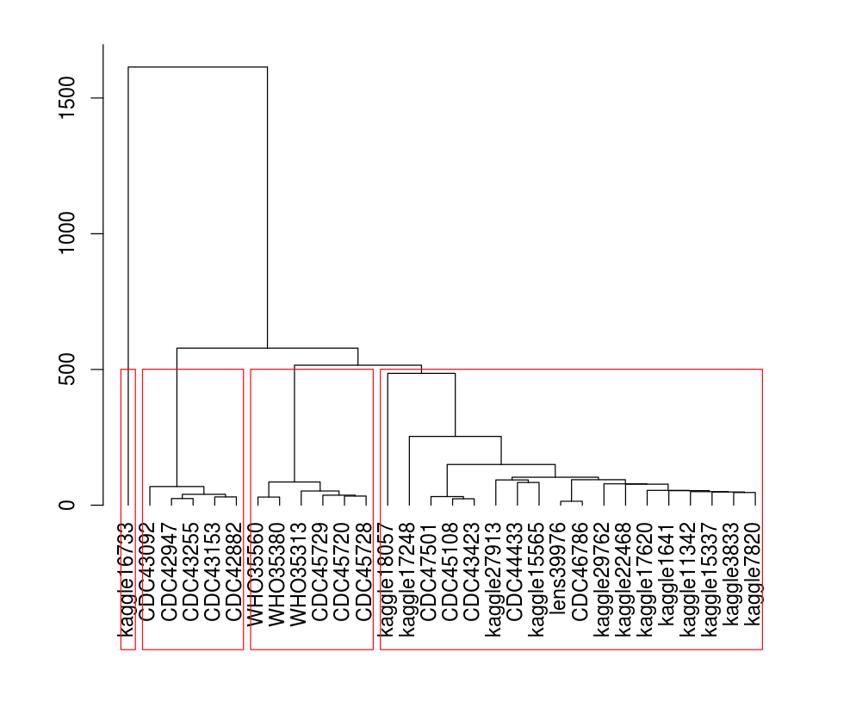

### Containment Measure Map

In tableau, we created a visualization indicating the number of containment measures in different countries from December 2019 to March 2020. From this graph, we found China first implemented containment measures, and had the most measures until February 2020. Russia, the United States, and a few other countries started their containment measures in February 2020. In March 2020, the coronavirus had spread around the world and all countries had instituted containment measures.

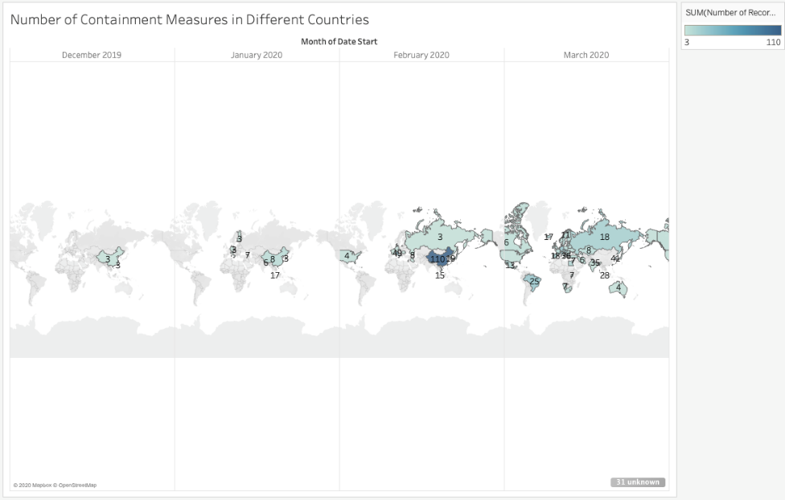

# Challenges

Our team had proposed to use the RStudio and Databricks integration. This integration is only available with the premium version of Databricks. Therefore, our team shared our code by exporting the Databrick’s notebook to an RMarkdown file.

## Updated Architecture



Another challenge we faced was translating the non-English rows of the dataset, discussed earlier. We plan to translate these rows and include them in our future work.

# Results Discussions

We used various text mining and natural language processing techniques to analyze our literature. Using word/document frequency, clustering and topic modeling, we were able to understand what the documents in our datasets were about, identify terms used frequently in the text, and group similar documents together. Using these results, we can now identify documents containing terms related to risk factors. Once we have all documents identified, our team can then drill down to discover what these documents can tell us about risk factors.

We also analyzed containment measures and identified that the most common measures are distancing, closures, cancellations, quarantines, and isolations. We will perform additional analysis to understand the measures used in countries that have effectively controlled the spread of COVID-19.

# Future Work

* Translation of non-English row of literature dataset
* Additional analysis of all literature documents related to risk factors
* Identify effective containment measures

# Conclusion

COVID-19 is causing a global crisis. The virus is impacting populations around the world, and many businesses and schools are closed. The healthcare system is struggling to handle large numbers of cases while dealing with shortages of the necessary supplies and equipment. The Kaggle COVID-19 Open Research Dataset Challenge (CORD-19) seeks to assist the scientific community in gaining insight and understanding about the virus. Using natural language processing and text mining techniques (clustering, topic modeling, and word/document frequency), our team explored the dataset, gained an understanding of the data, and identified the relevant data for additional analysis. Through further analysis of our data, we believe our team will address the research question, "What do we know about COVID-19 risk factors, and what have we learned from epidemiological studies?"

# References

ACAPS. "ACAPS COVID-19: Government Measures Dataset - Humanitarian Data Exchange". *Data.Humdata.Org*, 2020, https://data.humdata.org/dataset/acaps-covid19-government-measures-dataset. Accessed 16 Apr 2020.

Amazon Web Services. *Docs.Aws.Amazon.Com*, 2020, https://docs.aws.amazon.com. Accessed 23 Apr 2020.

CDC. "Coronavirus Disease 2019 (COVID-19) Situation Summary". *Centers For Disease Control And Prevention*, 2020, https://www.cdc.gov/coronavirus/2019-ncov/cases-updates/summary.html#risk-assessment. Accessed 24 Apr 2020.

Epidemicforecasting.org. "Containment Measures Database". *Epidemicforecasting.Org*, 2020, http://epidemicforecasting.org/containment.

h2o. "Home - Open Source Leader In AI And ML". *Open Source Leader In AI And ML*, 2020, https://www.h2o.ai. Accessed 24 Apr 2020.

kaggle. "COVID-19 Containment And Mitigation Measures". *Kaggle.Com*, 2020, https://www.kaggle.com/paultimothymooney/covid19-containment-and-mitigation-measures. Accessed 17 Apr 2020.

kaggle. "COVID-19 Open Research Dataset Challenge (CORD-19)". *Kaggle.Com*, 2020, https://www.kaggle.com/allen-institute-for-ai/CORD-19-research-challenge. Accessed 24 Apr 2020.

Organisation for Economic Co-operation and Development. "OECD Updates G20 Summit On Outlook For Global Economy - OECD". *Oecd.Org*, 2020, http://www.oecd.org/newsroom/oecd-updates-g20-summit-on-outlook-for-global-economy.htm. Accessed 13 Apr 2020.

r-project.org. "R: The R Project For Statistical Computing". *R-Project.Org*, 2020, https://www.r-project.org. Accessed 22 Apr 2020.

Robinson, Julia. "Text Mining With R". *Tidytextmining.Com*, 2020, https://www.tidytextmining.com. Accessed 24 Apr 2020.

RStudio. "Rstudio | Open Source & Professional Software For Data Science Teams".

*Rstudio.Com*, 2020, https://rstudio.com. Accessed 22 Apr 2020.

Shmueli, Galit, et al. *Data Mining for Business Analytics*. New Jersey: Wiley, 2018.

The Lens. (2020). The Lens - Free & Open Patent and Scholarly Search. Retrieved 27 April 2020, from https://www.lens.org

Weller, Christian. "What We Know About The Economic Impact Of The Coronavirus And How That Should Guide Policy". *Forbes*, 2020, https://www.forbes.com/sites/christianweller/2020/03/19/what-we-know-about-the-economic-impact-of-the-coronavirus-and-how-that-should-guide-policy/#49281627375f. Accessed 13 Apr 2020.

World Health Organization. "Coronavirus". *Who.Int*, 2020, https://www.who.int/health-topics/coronavirus. Accessed 13 Apr 2020.